Megan Finfrock, Caden Heyen, Caleb Reed, Cassidy Thomas, Jake Toma

Professor Hutchins

ACE 592 SAE

13 May 2022

**Group Project Final Paper**

# **Motivation**

Farmers face risk from various sources throughout the production cycle and each farmer has a unique risk preference. Risk for farmers can fall into two broad categories: business risk, and financial risk. Business risk is generally reflected in the variability of net cash flows externally impacted by the market for inputs and outputs and in environmental factors that affect production variability (Gabriel & Baker, 1980). Financial risk is also reflected in the variability of net cash flows but is defined by the fixed financial obligation associated with debt financing and cash leasing (Gabriel & Baker, 1980).

When deciding on a topic for our project we looked into the concept of risk balancing. Under the theory of risk balancing, we are assuming that the farmer has identified farm survival and profit maximization as primary goals for the farming operation. Under this assumption, a lexicographic utility function exists where the farmer will maximize their net returns subject to the constraint that total risk does not exceed their specific risk preference level (Gabriel & Baker, 1980). Risk balancing refers to the farmer making adjustments to the two components of total risk; business risk and financial risk due to external shocks to the existing risk balance. As one component of total risk shifts, the other component will make the opposite shift, keeping the total risk the farmer faces below their risk preference constraint.

Our motivation for the project was to determine if the concept of risk balancing is relevant in farmers' decision-making related to land rental agreements. Many factors go into the farmer and landowners' decision of what type of land rental agreement to use such as simplicity of agreement, level of involvement, land control preferences, risk preferences, etc. When developing this idea we decided to focus on the risk preferences and risk associated with two different land rental agreements: cash rent and crop share. Cash rent agreements require the farmer to pay a fixed rental price for the use of the land while assuming all the risks associated with the production of the crop. Crop share agreements differ in that the farmer and the landowner share in the risk and the return from the land. Within these two land control agreements, the cash rental agreement increases the risk exposure of the farmer as compared to the crop share agreement.

If risk preferences play a role in the decision to cash rent vs. crop share we would expect to see a gap between the cash rental rate and the expected rental rate of the crop share agreement. Historically, this is not the case. Cash rents tend to lag changes in net-share rents causing cash rents to be higher than net share rents for many years (Lattz, 2017). This showed us that farmers are not receiving a risk premium for the additional risk of operating under a cash rental agreement. When viewing this through the theory of risk balancing, this would indicate that farmers are making a risk adjustment elsewhere in their operation to allow for the additional business risk added with the use of a cash rental agreement. One possible explanation for the risk adjustment farmers are making based on their land rental agreement choices could be crop insurance.

**Background**

Federal crop insurance was first authorized by Congress in the 1930s, with the Federal Crop Insurance Corporation’s (FCIC) creation in 1938. Although initially an experiment for major crops, the 1980 Act set forth a substantive crop insurance program for farmers of various crops and in different regions. In the last approximately forty years, many changes have occurred in this legislation, including the establishment of the Risk Management Agency (RMA) to administer FCIC programs. Both nationally and locally, enrollment and coverage levels have evolved, due in part to shifting risk preferences and additional governmental support.

Land ownership among farmers has also changed over the past several decades. At the state level, more Illinois farmland is being cash rented than share rented over time (Schnitkey, Paulson, Zulauf & Swanson, 2021). For Farm Business Farm Management farms, the number of cash rented acres grew from 25 percent in 1995 to 32 percent in 2001 (Lattz, Schnitkey & Sherrick, 2002). Cash rental leases are stickier with respect to farmland returns than share rental agreements. As such, a farm’s financial position becomes more closely related to the level of cash rents relative to farmland returns as more farmland is cash rented. This, of course, has implications for future farm lease types and, as we will discuss in this paper, potentially risk preferences among farmers.

Current trends indicate that farmers are taking on rental agreements with higher levels of risk, due possibly to balancing with crop insurance. While additional risk is expected to correspond with increased profits, this has not been the case with farm cash rental agreements. The introduction of crop insurance revenue protection in 1997 may offer one explanation. By countering some of the risks related to crop insurance with revenue protection, farmers could be willing to assume greater risks in rental agreements. Most Illinois farmers use revenue protection at higher coverage levels for both corn and soybeans, with this type of coverage accounting for 79.3 percent of planted acres (Schnitkey, 2019).

Literature concerning farmer risk preferences, crop insurance coverage, and land lease types is relatively scarce. As such, there is a need to evaluate current trends and their implications for farmers in Illinois. Using farm and county-level data to analyze risk preferences, we will examine whether risk preferences predict Illinois farmland lease types, as well as what the shift in lease types over time implies about changes in risk preferences.

### **Data**

The data for this analysis includes county-level data from the Illinois Farm Business Farm Management (FBFM) system. This data provides financial information, such as debt-to-asset ratios, by county averages for the years 2003 to 2020. This dataset also includes the number of acres covered by three lease types: cash rentals, share rentals and owned land. This includes the following variables and descriptions:

* Year
* FBFM Code: Denotes county
* Debt_to_asset: Average debt/asset ratio for farms in each county.
* Cash_acres: Total cash rented acres in each county.
* Share_acres: Total share rented acres in each county.
* Owned_acres: Total owned acres in each county.
* SPR: The average soil productivity rating for farms in each county.

Cash rented here is defined as a fixed cash lease in which the farmer pays the landowner a fixed payment to rent the farmland. Share rented acres in this context involves the sharing of revenue and direct costs between the farmer and the landowner. Owned acres, then, is the farming of land which the farmer owns.

We will also employ Summary of Business data from the United States Department of Agriculture Risk Management Agency. These crop insurance files contain data summarized by the state, county, and crop level, and include the coverage level for commodities extending from 1989 to 2022. This dataset provides specific information about coverage types and levels, policies and subsidies, and the indemnity amount and loss ratio. To maintain consistency with the FBFM data, we will only use the crop insurance data for 2003 to 2020. The variables for the crop insurance can be further explained by the following:

* Commodity Year: The identifier that represents the year in which the crop/commodity is normally harvested and indicates the policy year for which coverage was provided.
* State Code: The FIPS code that denotes the State in which the insured farm is located.
* State Abbreviation: USPS state abbreviation.
* County Code: A FIPS code indicating the county in which the insured farm is located.
* County Name: Name of the county.
* Commodity Code: The Risk Management Agency (RMA) code that denotes the crop/commodity for which the policy is issued.
* Commodity Name: Name of the crop/commodity.
* Insurance Plan Code: Code that denotes the type of insurance coverage is selected for the insured crop (e.g.APH, Revenue, Dollar, etc.)
* Insurance Plan Name Abbreviation: Abbreviation of the Insurance Plan Name.
* Coverage Level: Elected by the insured, its complement is the deductible. The base to which it applies differs by insurance plan (e.g. - yield, revenue, dollar, or inventory).
* Policies Sold Count: The number of policies reported to RMA as being sold.
* Net Reported Quantity: Number of acres, tons, pounds, etc. reported as being planted adjusted by the insured’s share in the commodity. (e.g. reported acres * insured’s share)

These data are publicly available from their respective agencies. Please refer to the “references” section to access these sources.

### **Methodology**

Using farm and county-level data, we are analyzing risk preferences to examine whether risk preferences predict Illinois farmland lease types and what the shift in lease types over time implies about changes in risk preferences. The period under our scope is 2003 through 2020 for both the FBFM lease type data and the USDA insurance data.

After importing our libraries and declaring our variables, the approach we chose to use was first to break down our FBFM lease type data to show the change in lease types over time and draw our first conclusion. After grouping the data by year, we produced a bar graph illustrating the number of acres by each lease type - cash, share, and owned acres - from 2003 to 2020.

We then created our first directory, titled d01, in the jupyter notebook dashboard. This directory houses all of the files concerning the FBFM lease type data. We also created an additional directory, titled d02, containing all of the Illinois shapefile data. With those directories created, we could read in the Illinois shapefile and the FBFM lease type data for each year. Before merging the two files, we had to rename a column within the shapefile to ensure the files would unite on the correct column.

With all of these documents read in, we merged the lease type data with the shapefile for each year on the county column of both files. We mapped the percent of cash acres for each individual year on top of the geographical data. With each of those maps, we created an animation that paints a picture of how the percentage of cash acres has changed over time. This is where we drew our third conclusion.

From here, we dove into the insurance data from the USDA. When we acquired the data, it was in individual comma-separated values. Using the OS module, we created a combined comma-separated value spreadsheet with insurance data from 2003 to 2020. The combined file allowed us to create a plot showing each year's total Illinois acres insured; with this information, we could draw our fourth conclusion. Additionally, we created a line plot showing the average insurance coverage with the same data helping us come to our fifth conclusion.

Finally, we created a third directory with each year of insurance data titled d03. We then read the data, grouped the columns by county, and summed them. We were able to strip the data so that the columns in the insurance data matched those in the shapefile, eventually allowing the two to merge. Like the FBFM data, we took the USDA data and overlaid it with the geographical data included in the shapefile. This was to create an additional animation showing how insurance coverage in each county within Illinois has increased during our specific examination period. These maps lead us to our fifth and final conclusion.

### **Discussion and Results**

After running our analysis in Python, we can draw multiple conclusions from the data. The first conclusion we can draw is that farmers are switching to cash lease types and shifting away from shared lease types in the state of Illinois. Shared leases dominated the choice for farmers from 2003 to 2008, with 2005 being an exception. There are many possible reasons why this shift occurred over time. One big possibility that will be covered later in this paper is that it could be that crop insurance takes enough risk away for the farmer to accept all of the risks on the land, rather than sharing it with the landowner. Another possible reason is the massive government payments to farmers. Over time, we see that government payments to farmers have increased significantly. Whether it be pandemic payments, the drought of 2012, or major flooding in the Midwest in 2019. Farmers have received big payments which could lead to them wanting to take on all of the acres of land via cash rent. Additionally, it could be the preferences of landowners and farmers that have led to the change in lease types. It could be that landowners prefer renting all of their land via cash rent and giving all of the risk to the farmer. It could also be that the farmer prefers taking all of the profit that comes with cash rents and not having to split profits when in a share rent agreement. In the figure below, the orange line represents shared rent agreements and the blue line represents cash rent agreements. The orange line (share rent) is clearly the choice for Illinois farmers in the early 2000s. It is not until 2009 that the shift occurs, and the blue line (cash rent) overtakes share rent lease types. From 2013 to 2020, the gap between the uses of each lease type widens, and cash rent dominates the choice for farmers.

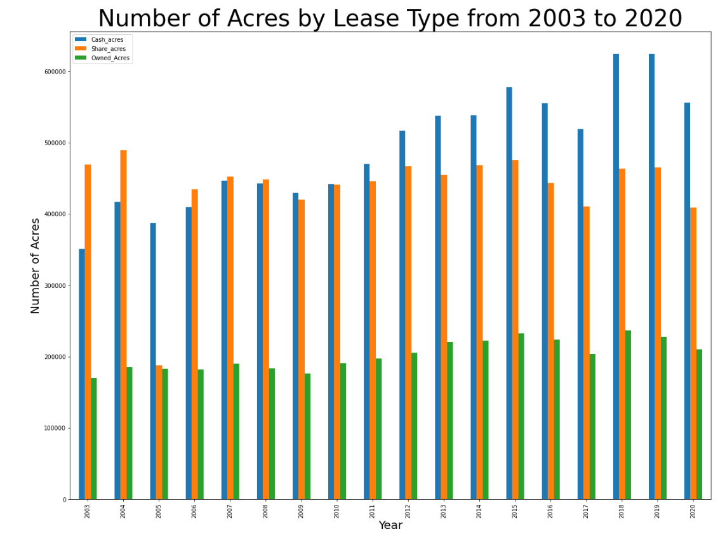

The second conclusion that can be drawn from our data is that throughout the counties of Illinois, the percentage of farmers using cash rent is increasing over time. It can be concluded that Illinois as a whole is seeing an increase in cash rent but the same can be said for certain counties in Illinois as well. Below is a side-by-side comparison at the county level of Illinois that shows an increase in cash rent from 2003 to 2020. Counties that turn a darker blue have seen an increase in cash rent over time.

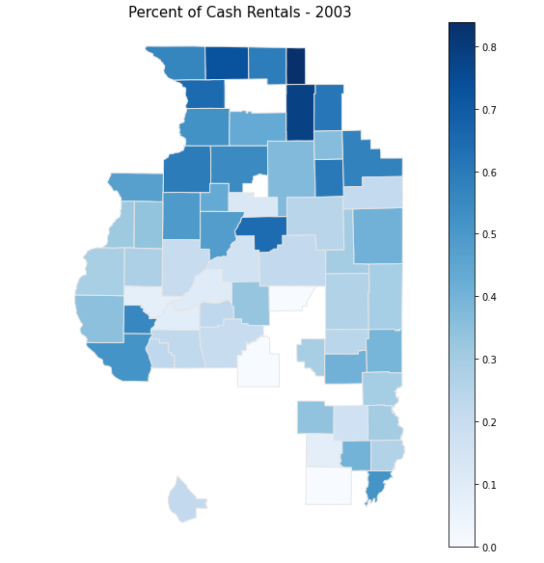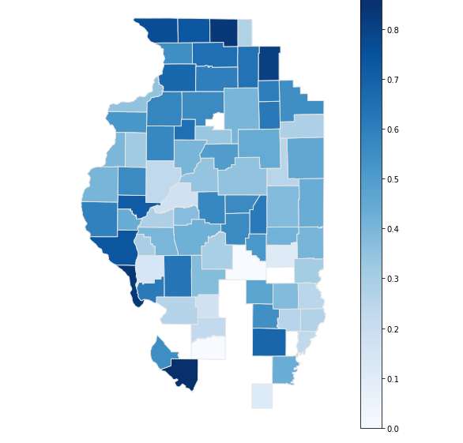

A third finding that can be drawn from the plethora of data is that Illinois farmers have increased their coverage of acres with crop insurance. In 2003, the net quantity of acres covered by crop insurance in Illinois was just under 15 million. The net reported quantity of acres covered in 2020 was just under 20 million. In 17 years, the number of acres covered by crop insurance increased by almost 5 million. The figure below shows the increase in the net reported quantity of acres insured between 2003 and 2020.

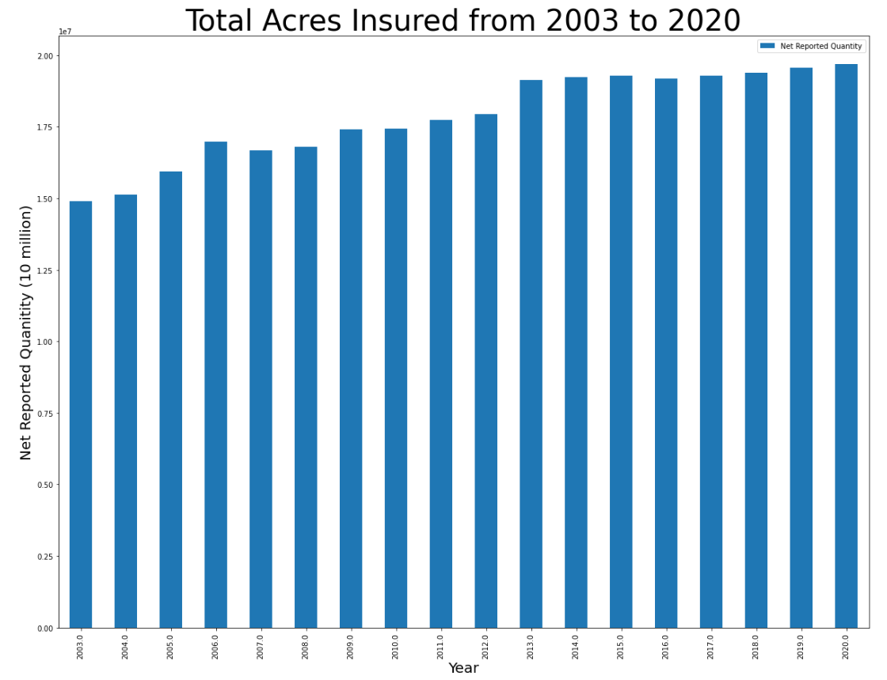

Coverage levels have not always increased between 2003 and 2020. In 2003, coverage levels were at about 69%. They then rose from 2003 to 2008 but then dipped until 2012. Since 2012, they have been on the rise. It can be implied that the drought of 2012 contributed to farmers' fears of something of similar impact happening again. Farmers no longer wanted to take on the risk of not having their crops covered by insurance. Government payments did help some farmers but many faced the consequences of not being insured. Farmers in Illinois have decided to financially cover their crops in case of misfortune like the drought of 2012.

The state of Illinois as a whole has seen an increase in the number of acres covered by crop insurance and in unison certain counties in Illinois have too. In the side-by-side comparison, it can be concluded that many counties saw an increase in the average coverage level with crop insurance. The darker shades of red indicate higher levels of coverage. 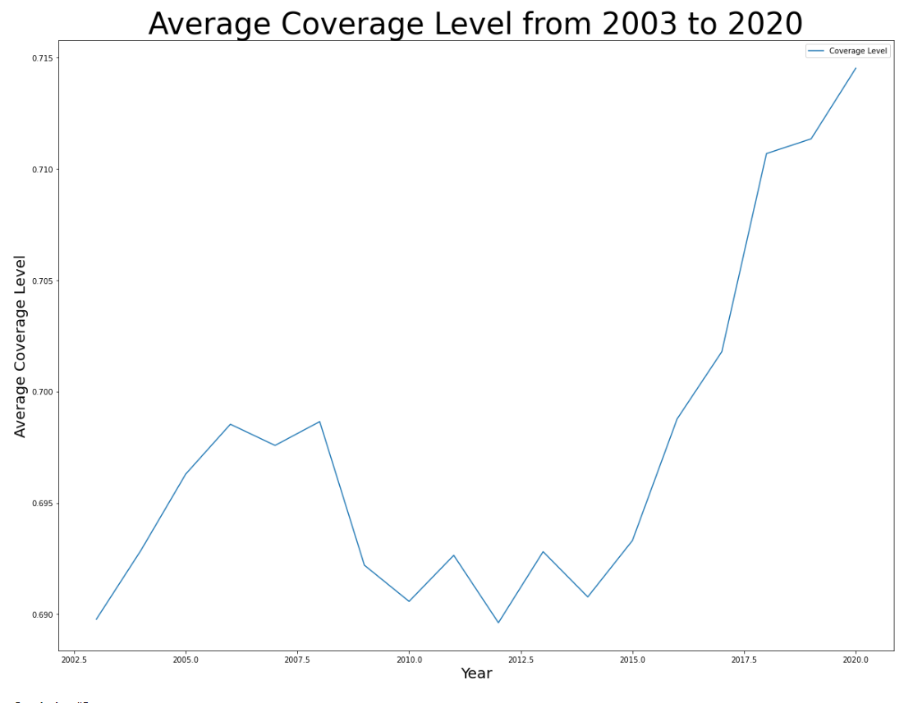

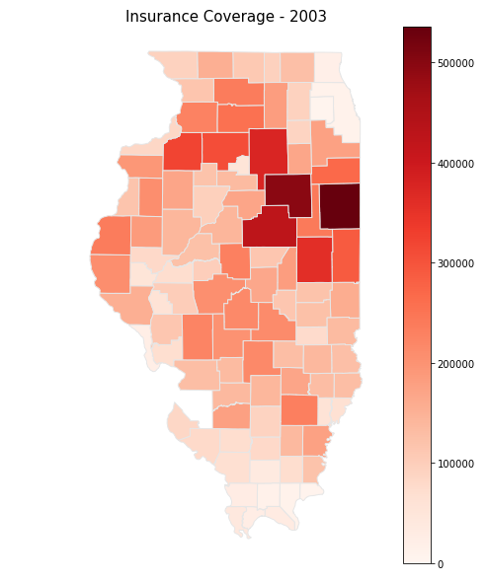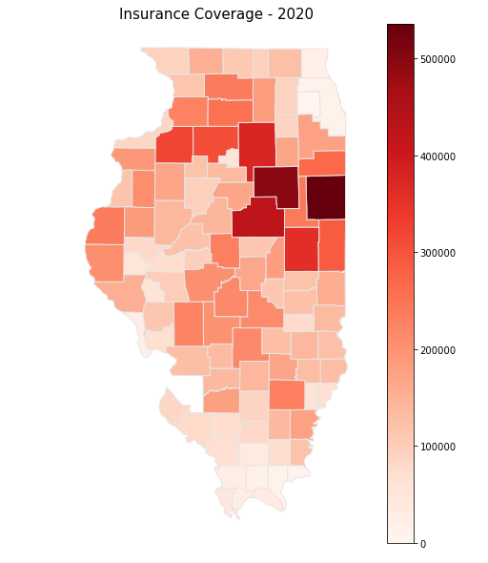

These findings show just how complex agriculture can be. Agriculture is one of the most important industries in the United States. There are so many factors that can impact agriculture that must be taken into consideration. All of our conclusions open up discussion as to what behavior farmers are adjusting towards.

**Missing Data**

Analyzing farmland lease type data and crop insurance has allowed us to paint a picture of trends in Illinois over time. However, there is likely more to correlate these trends to over the course of many years outside these two parameters alone. There are several other factors we would have liked to include in our analysis given we had data that aligned with the other FBFM files. FBFM only tracks farms in their system and does not collect data from every Illinois farmer. Collecting data on farm incomes, extreme natural occurrences, economic climate, and farm size would have allowed a clearer picture as to why the data varies at certain points in time. Farmer risk preferences could be better explained by factoring in these other data sets had they been at our disposal.

Tracking individual farmer income was perhaps the most important set of data we would have utilized. Farmer risk at a high level is gauged by how their net income will be impacted based on both their input decisions and set market levels. Answering the question, “How has relative farm income changed after the introduction and increasing use of crop insurance in Illinois?” would tell a great deal about the relationship between income risk and crop insurance. Due to insurance being a guarantee for compensation against different revenue barriers, we would expect net incomes to rise (while also factoring inflation, commodity/input prices, etc.) Noting 79.3% of corn and 76.5% of soybean acres in Illinois utilized Revenue Protection in 2018 (Schnitkey 2019), a substantial number of farmers have taken on revenue insurance as standard practice. Finding net income has fallen relative to years before the introduction of Revenue Protection crop insurance would raise speculation about the effectiveness of crop insurance at standing premium levels.

Climate variation and pest data would have been next. These variations analyzed by years that experienced extreme rainfall, drought, wind, or destructive pests would have expanded our outlook on if farmers react differently in the years following. This category is less likely to occur in consecutive years and would be best highlighted in a plot with vertical line indicators. Checking for volatility in crop insurance usage after a disastrous year or decline in usage after a period of prosperous yields would help pinpoint if farmer risk preferences change due to natural occurrences.

Economic and political impacts would be analyzed similarly. The frequency of these major changes tends to come in spurts: a year or a few years at a time before the next major issue arises. Wars between major players in the production and/or consumption, changes of power/elections, and depressions are among a few of these major issues. Much like natural disasters, tracking these instances may allow us to see a point in time where a major shift started to develop in the farming community.

The impact on lease type and crop insurance selections due to farm size in acreage is last and maybe influencing our current data the most. Identifying lease and insurance differences between those farming several thousands of acres and those farming tens to hundreds could allow a glimpse of how risk decisions change with size. Would the data project smaller farmers take on less risk or be more aggressive in hopes to expand? Are larger farms taking more secure approaches or using size as a safety blanket to reach for higher revenue streams? Seeing as the data we utilized is grouped by total acreage per county it was impossible to distinguish if large farms are influencing the data by volume and not by what the typical farmer is employing in their practices. This factor along with the others listed in this section would have provided great insight into why we are identifying trends in farmland lease type and crop insurance.

### **Conclusion**

Our data science project has only touched the surface in discussing lease types and crop insurance coverage levels. Our data suggest that farmers in Illinois will continue to go more towards cash rent agreements rather than shared rent agreements. The gap between cash and shared rents for farmers in Illinois continues to expand which implies in the future that we see farmers becoming more risk-taking and continuing the trend of going to cash rents. Our data also deduces that farmers in Illinois will continue to expand crop insurance coverage of their land. Future trends suggest that crop insurance coverage levels will continue to increase, as seen by the trend in our graphs and by looking at the numbers. Other things to consider when it comes to this topic are political and economic concerns for agriculture/farmers, climate variation and other natural impacts, and changes across different types of crops such as corn vs. soybeans. When considering the political environment concerning agriculture/farmers, there is a farm bill that is usually passed every five years by Congress. The farm bills usually include support for farmers as well as additional support for areas such as nutrition, trade, conservation, commodity programs, and rural development. This type of support is extremely important to consider when analyzing the trend of risk-taking or risk-averse farmers. Something to possibly add to this type of research question is, to what extent do these farm bills influence the number of risks farmers are willing to take? As mentioned above, big government payments give farmers a huge lump sum of money. This is money that goes towards their income and can be used to expand their farms by buying equipment, fertilizer, and other important things to maintain operation.

### 

### **References**

Gabriel, S. C., & Baker, C. B. “Concepts of Business and Financial Risk.” American Journal of Agricultural Economics, 62(3), 560–564. <https://doi.org/10.2307/1240215>, August 1, 1980.

Lattz, D. "[Fixed Cash Rental Rates Diverge from Farm Earning Since 2013](https://farmdocdaily.illinois.edu/2017/02/fixed-cash-rental-rates-diverge-farm-earning.html)." farmdoc daily (7):25, Department of Agricultural and Consumer Economics, University of Illinois at Urbana-Champaign, February 10, 2017.

RMA. *State/County/Crop Summary of Business*. USDA.gov, 2003-2020,

https://www.rma.usda.gov/en/Information-Tools/Summary-of-Business/State-County-Cro p-Summary-of-Business.

Schnitkey, G., N. Paulson, C. Zulauf and K. Swanson. "[Trends in Farmland Leasing](https://farmdocdaily.illinois.edu/2021/09/trends-in-farmland-leasing.html)." *farmdoc daily* (11):138, Department of Agricultural and Consumer Economics, University of Illinois at Urbana-Champaign, September 28, 2021.

Schnitkey, G. "[Revenue Protection Most Popular Crop Insurance Choice in Illinois](https://farmdocdaily.illinois.edu/2019/01/revenue-protection-most-popular-crop-insurance-choice-in-illinois.html)." farmdoc

daily (9):16, Department of Agricultural and Consumer Economics, University of Illinois at Urbana-Champaign, January 29, 2019.